BOCLAIR ACADEMY
Parent Council Meeting
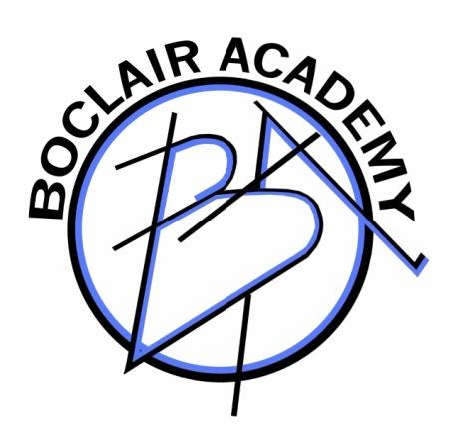

Monday 15.05.23 (6.30 pm in school)

Present: Chris Allen, Gaynor Bilton, Elaine Dallas, Varinder Dhaliwal Dominic Gonzalez, Kirsteen Graham, Jenny Kerr, Susan Lang, Joanne McArthur, Geoff Miles, Jillian Mooney, Graham Murray, Chris Sheerin & Councillor Gallagher.
Staff: Douglas Brown, Fiona Curran, Glenn Thomson, Amy Thompson, Maxine Traynor and Nick Walsh.

- Welcome & Apologies
Geoff Miles opened the meeting and thanked everyone for their attendance.
Apologies: Ruth Candy, Jill McIntyre, Flora Thomson,

- Minutes of last meeting
Minutes of the meeting of 27.03.2023 were approved by Chris Allen and seconded Kirsteen Graham. Head Teacher report will be added before publishing minutes on website.

- Matters Arising
The Matter of Mental Health Awareness was risen, but Douglas Brown will cover that in his report.

- Summer Fayre Update

It was reported that there will be approximately 20 staff had volunteered to help out at the Spring Fayre. Parent council will cover stalls and provide Hot Dogs/Burgers & Chips. There will be home baking stalls, drinks, sweets and crisps. PC will also cover crazy hair and tattoos. PC will purchase the face paints and the school will provide volunteers to carry out the face-painting. There will also be a bouncy Castle. It was decided not to have a book/CD stall as it is always very difficult to get rid of stock left-over at the end. Donations can be handed into the school, or dropped off on the Friday evening before the Fayre.

- Head Teacher’s Report

School activities over last term

- Spring Revision
- Study weekend
- S3 Café Work Experience
- Rights Respecting School Ambassadors Assembly
- Dementia Friends Café – musical performances
- John Muir work started
- Museum of flight visit
- Professional Learning sessions
- Girls Football Awards
- S1-S3 Inter class games
- P7 Information events
- Paintballing
- Prom
- BGE Awards Ceremony – potentially 2
- Summer showcase 7th June

Staffing update

- New classroom assistants appointed – Anna Quinn and Amy Woods
- New Science Technician – Jake MacLeod
- New Technical Technician appointed – Alex Rollings
- New PT Guidance appointed – Dom Martin
- New PT Equity – Amanda Daly
- New Maths teacher appointed – Miss Richy Dolan
- New Business teacher appointed – Miss Chesney

Current recruitment for:

- ICT Analyst
- Art
- English
- PE & Dance
- PT Music
- School Support Manager
- DHT

Currently waiting for our NQT allocation. Following this, further recruitment may be required.

SQA exams update

Half way through the diet
Most are taking place in the large games hall
Increased number of exceptional circumstances
Change to the start of new timetable to accommodate the coronation

Mental Health and wellbeing

The Boclair Academy Mental Health and Wellbeing strategy was discuss in detail. This outlined approaches in the school following discussion at a previous meeting regarding Mr Swan’s presentation on the wider EDC approaches.

Self-evaluation – parent views

Parent Council took part in a self-evaluation exercise looking at the areas where the school are doing well, and then the areas they would like the school to work on next session. This will form part of the School Improvement Plan next session.

- Date of Next Meeting
Next Meeting will be the AGM – date to be advised after Summer.

- AOCB – To be discussed at future meetings
Education Committee
LGBTQ Charter – progress update – what level had been obtained.

